**PROBLEM STATEMENT**

Customer Segmentation Using Machine Learning.

BY:

Team No:08

R.Bhargavi Reddy

S.Jyothika

S.Dhatrija

**APPROACH:**

**K-means Clustering Algorithm:**

K-means Clustering is a clustering Algorithm in which we are given with data points with its data set and features and the mechanism is to categories those data points into clusters as per their similarities. The algorithm forms K clusters based on its similarity. To calculate the similarity Kmeans uses Euclidean distance measurement method. Steps i. In first step, we randomly initialize k points. ii. K-means classifier categorizes each data point to its nearest mean and rewrite the mean’s coordinates. iii. Iteration is continuing up till all data points are classified.

**Steps:**

1. Import the required software libraries.

2. Load the data.

3. Data Analysis.

4. Data Cleanup and Transformation.

5. Normalize the Data.

6. Visualize the Data

7. Discover Insights about Customers.

**RESULT:**

**Elbow Method:**

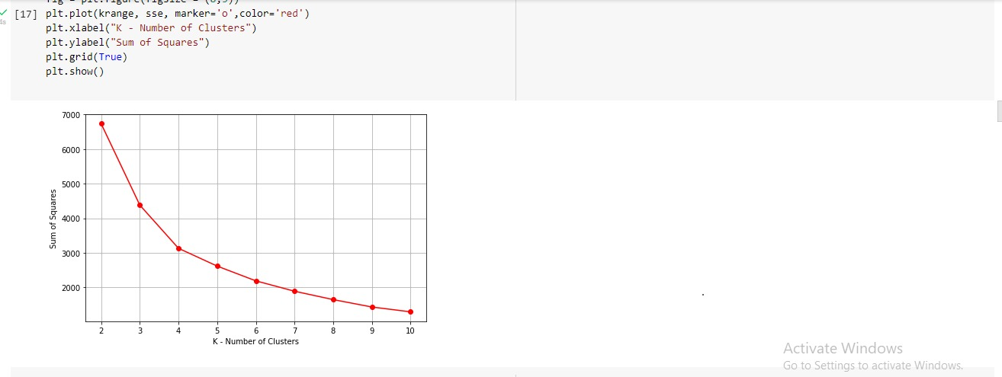

**Visualize the relationship between Average Order Value and each Cluster:**

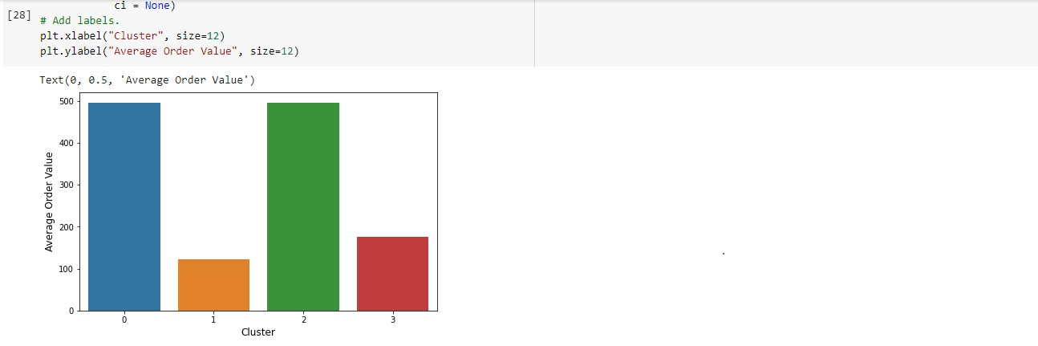

**Visualize the relationship between Order Count and each Cluster:**

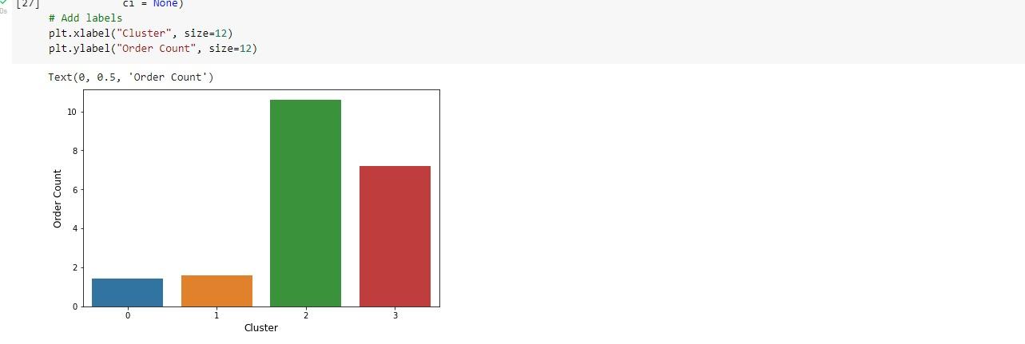

**Visualize the cluster for Total Sales by Order Count:**

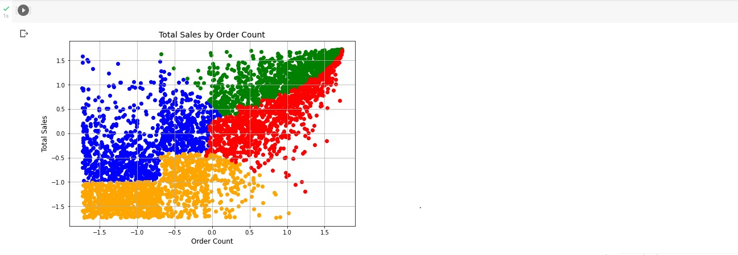

**Visualize the clusters for Average Order Value by Order Count:**

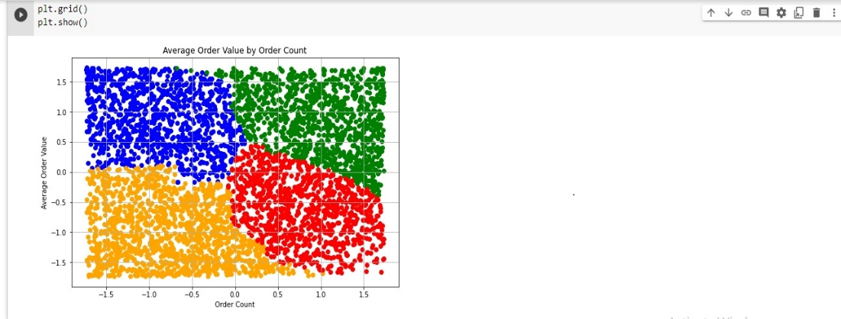

**Visualize the clusters for Average Order Value by Total Sales:**

